Salma Bibi
Curriculum Vitae

Profile
As a detail-oriented Customs Agent at DHL Aviation, I'm deeply engaged in airport operations and now seeking opportunities as an Operations Service Agent at Norwegian. With substantial experience in the regulated airport industry, I possess a strong foundation in airport operations that aligns perfectly with the demands of your company. My attention to detail, combined with my ability to perform under pressure, empowers me to efficiently manage operations related to import flights within the customs department. I excel in communicating and coordinating with both third-party suppliers and internal departments, consistently driving towards operational targets. Proficient in both Danish and English, I effectively convey information and collaborate with team members to accomplish objectives. I approach tasks with a proactive, organized, and adaptable mindset, ensuring optimal outcomes are consistently achieved.

Education

General Upper Secondary School (STX), Hvidovre Gymnasium
August 2018 — June 2019
I have successfully completed my Danish high school education.

Master’s in business administration, Virtual University of Pakistan
2010 — 2012
I completed a master’s degree in business administration.

Bachelor of Business Administration, University of Punjab
2006 — 2010
Completed bachelor’s degree in business administration.

Employment History

Customs Agent at DHL Aviation (CPH Airport)
October 2022 — Present
Full time
- Managed customs-related responsibilities and requirements for international trade clients.
- Oversaw import and export processes, including duties, taxes, customs, and regulatory compliance.
- Proficient in filling out and submitting customs documents and certificates.
- Facilitated communication and collaboration with government authorities and export or import partners.
- Demonstrated expertise in local and international customs regulations and procedures.
- Worked in collaboration with various DHL departments to ensure effective customs processing for clients.

Certifications:
Certified International Specialist (CIS).
Completed 2 days of 1 module: Customs training, with certification.
Completed Facilitator course, with certification.

Details
Dalvangsvej 71 1 tv
Glostrup, 2600
Denmark
+45 71 72 66 38
Salmabibi05@hotmail.com
Date of birth
08. August 1988

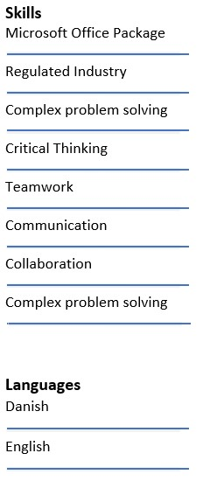

Hobbies
I enjoy exploring topics related to personal growth and leadership. This hobby has helped me to expand my knowledge, enhance my critical thinking skills, and stay motivated to continuously improve in both my personal and professional life.
I love to travel and explore the world. Travelling is not just a hobby for me; it is a passion, which allows me to break free from routine and enjoy life.

Administrative Assistant & Production assistant at Postnord
December 2016 — September 2022
Full time
- Proficient in scanning and managing packages efficiently.
- Skilled in preparing and organizing mail items.
- Experienced in administrative support for the leadership team.
- Proficient in handling customs-related packages.
- Maintaining different customers documents.
- Participating in different departments daily meetings.

Internship at Parkzone A/S
May 2016 — September 2016
Full time - internship
- Office Assistant in the administration department, provided essential support to the administration team.
- Telephone answering and customer service.
- Financial accounting managed financial records and transactions.
- Bookkeeping maintained accurate record of financial transactions and accounts.
- Archiving organized and preserved important documents and records.
- Handled procurement and product orders efficiently.

Opening & Closing Manager at Elite Købmand
Aug 2015 — June 2017 Part-time position
- Worked with the company's mission in mind and served as a committed and enthusiastic part of the Customer service team.
- Participate in the day-to day running of the store with responsibility for delegating tasks.
- Make decisions that follow the company's strategy.
- Follow-up/monitoring of other employees' task solving.
- Managed one-on-one personalized customer service experiences for customers of all ages.

Internal Auditor at Askari Bank
January 2012 — August 2013
Full time
- Evaluate financial documents for accuracy and compliance with company policies.
- Identify the financial risk of the organization and offer recommendations to reduce risk.
- Responsible for development and implementation of SOP’S
- Responsible for monthly, quarterly, and annual conduction of Audit.

